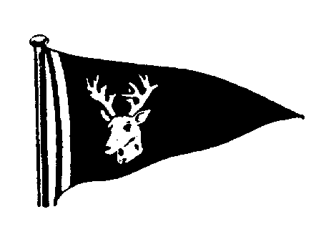

TSC Smack & Classic Yacht Race

7th October 2017

Name of Yacht/Smack……………………………………………………………………….

Class of Yacht……………………………………………………………………………………………

Handicap (Smack & Yacht) PY/OGA etc……………………………………………………

Colour of Hull……………………………………………………………………………………………...

Sail Number…………………………………………………………………………………………

Contact Name……………………………………………………………………………………………

Contact Address…………………………………………………………………………………………

………………………………………………………………………………………….
………………………………………………………………………………………….

Contact Number…………….…………………………………………………………………………..

Email…………………….………………………………………………………………………

Approx. Nos. of Crew requiring food…………...…………………………
(Just so we’ve got an idea of numbers.)

Please enclose your entry fee of £10.00. Cheques should be made payable to Tollesbury Sailing Club and returned to the address below.

Race instructions, entry forms etc. are also available on the Tollesbury Sailing Club website www.tollesburysc.com , from the address below or from the committee boat on the day.

Bing (Gary Smith)
4 Station Road
Tollesbury
Essex
CM98RA
Tel: 07720437820
Email bingweedon@aol.com

