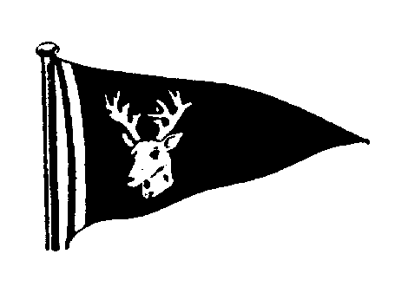

TSC Smack & Classic Yacht Race

The Tollesbury Sailing Club would like to invite you to its 2017 Smack and Classic Yacht Race on Saturday 7th October.

The event will take the form of a pursuit race for smacks (start times to be at the discretion of the TSC committee) and a handicap race for the classic yachts with class starts were appropriate.

As ever the racing will be followed by free beer on the hard at Tollesbury Marina and food (at a small cost) and entertainment will be provided in the TSC clubhouse alongside the Tollesbury Sail Lofts.

A water taxi (the Yellow Peril) will operate from the creek to the marina, limited berths may be available in the marina itself, to book contact the harbour master at:

Woodrolfe Boatyard

The Yacht Harbour
Tollesbury, Maldon, Essex, CM9 8SE
Telephone: Woodrolfe Boatyard 01621 869202

Fax: 01621 868489
Email: marina@woodrolfe.demon.co.uk

Our database of addresses for entrants to this event is far from complete so if you know of anyone else with a suitable vessel who would like to come along please do not hesitate to let them (or us) know.

Entry forms and race instructions can also be downloaded from our website: www.tollesburysc.com

We look forward to seeing you

Regards
Bing (Gary Smith)
Tollesbury Sailing Club
Tel: 07720437820
Email : bosun@tollesburysc.com

